Dashboard Introduction

1. Dataset

<https://www.kaggle.com/archit9406/customer-transaction-dataset>

This is the Open Data Source from Kaggle. It contains data of Customer and transaction. I have used three datasets that are Transactions, Customer Demographic, and Customer Geographic from the data and the relation among them in the Power BI is:

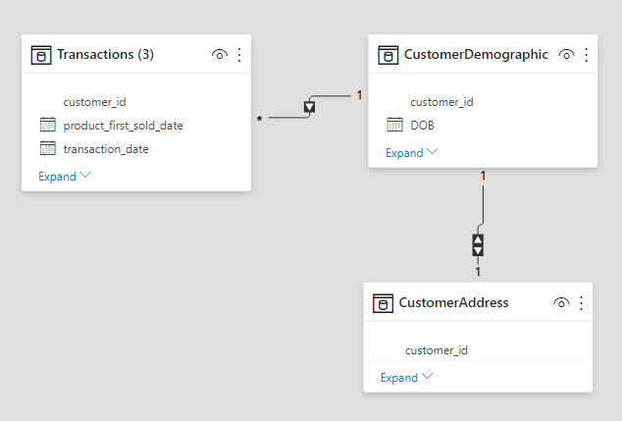

1. Dashboard

In the Dashboard, I mainly focus on the Customer information and which segmentations of it leads to most number of orders has been placed.

Visual 1 (# Order and Profit ($)): It shows the trends of Orders and Profits over time

Visual 2 (#Order by Job Industry): It shows the number of Orders placed by each Job Industry from Customers

Visual 3 (#Order by Wealth Segment): It shows the number of Orders placed by each Wealth Segmentation of Customer

Visual 4 (#order by Customer Demographic): It shows Customer Demographic Segmentation and each Segmentation contribution of #Order, Profit, and Margin. It is sorted by Profit.

Three drop down menu are focusing on the Product placed by customer and it controls the overall dashboard. Besides, four visuals in the dashboards are cross connected and each elements in it can control the overall dashboard by clicking it.